Project Development Phase
Testing and Validation
Date | 20 October 2026
Team ID | —————————————
Project Name | Car Rental Request Automation in ServiceNow Using Service Catalog and Workflows
Maximum Marks | 4 Marks
Purpose
Testing and validation confirm that the Car Rental Request Automation system behaves as intended and satisfies the defined requirements. The phase checks that the Service Catalog item, the Flow Designer automation, the approval process and the notifications work together without any manual hand-offs.
The tests follow the full workflow: a car rental order placed by the user, the email sent to the administrator, the administrator’s approval, and the final request status that the user can see. The aim is an accurate, stable system with a smooth user experience.
Test Environment
- Platform: ServiceNow (Personal Developer Instance)
- Modules used:
  - Service Catalog (the Car Rental Request catalog item)
  - Flow Designer (approval and fulfillment automation)
  - Approvals (sysapproval_approver) and Requested Items (sc_req_item)
  - Email notifications
- User roles involved:
  - Employee / Requester
  - Administrator / Approver (office registration)
Test Scenarios Executed
These scenarios were run to validate the system:
- Submitting a car rental request through the catalog item
- Capturing the pick-up, drop, duration and car details
- Sending an email notification to the office / administrator
- Approval of the request by the administrator
- Automatic status update and verification by the user
Testing Execution Details
Scenario 1: Car Rental Request Submission
- The user opens the Car Rental Request item in the Service Catalog.
- The user fills in the required fields:
  - Requestor
  - Requested Date
  - Pickup Location (starting point)
  - Drop Location (ending point)
  - Duration
  - Car Type
  - Reason
- The user clicks Order Now. The request goes through with no validation errors and the message “Thank you, your request has been submitted” appears along with the request number (REQ0010002 in this test).
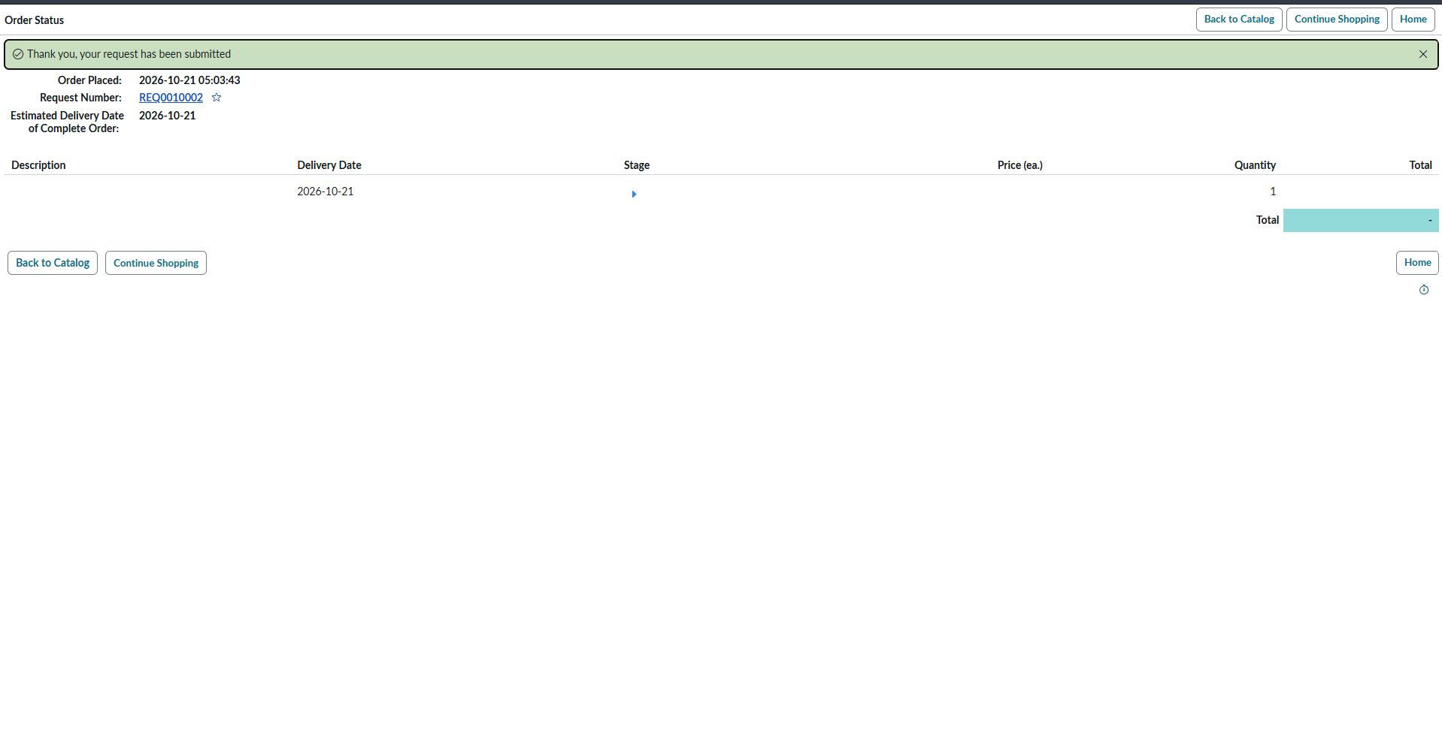
Figure 1: Order Status page after the car rental request is submitted
Scenario 2: Flow Trigger and Email Notification
- When the request is submitted, the Flow Designer automation starts by itself and creates the request (REQ) and requested item (RITM) records.
- An email notification about the new car rental request goes to the office / administrator.
- The administrator reads the email and confirms that the request details arrived correctly.
Scenario 3: Administrator Approval
- The administrator opens the approval for the requested item and chooses Approve for the vehicle request.
- The Approvals list shows the approval record for the requested item (RITM0010003 in this test) in the Approved state, approved by the administrator account, with the date and time recorded.
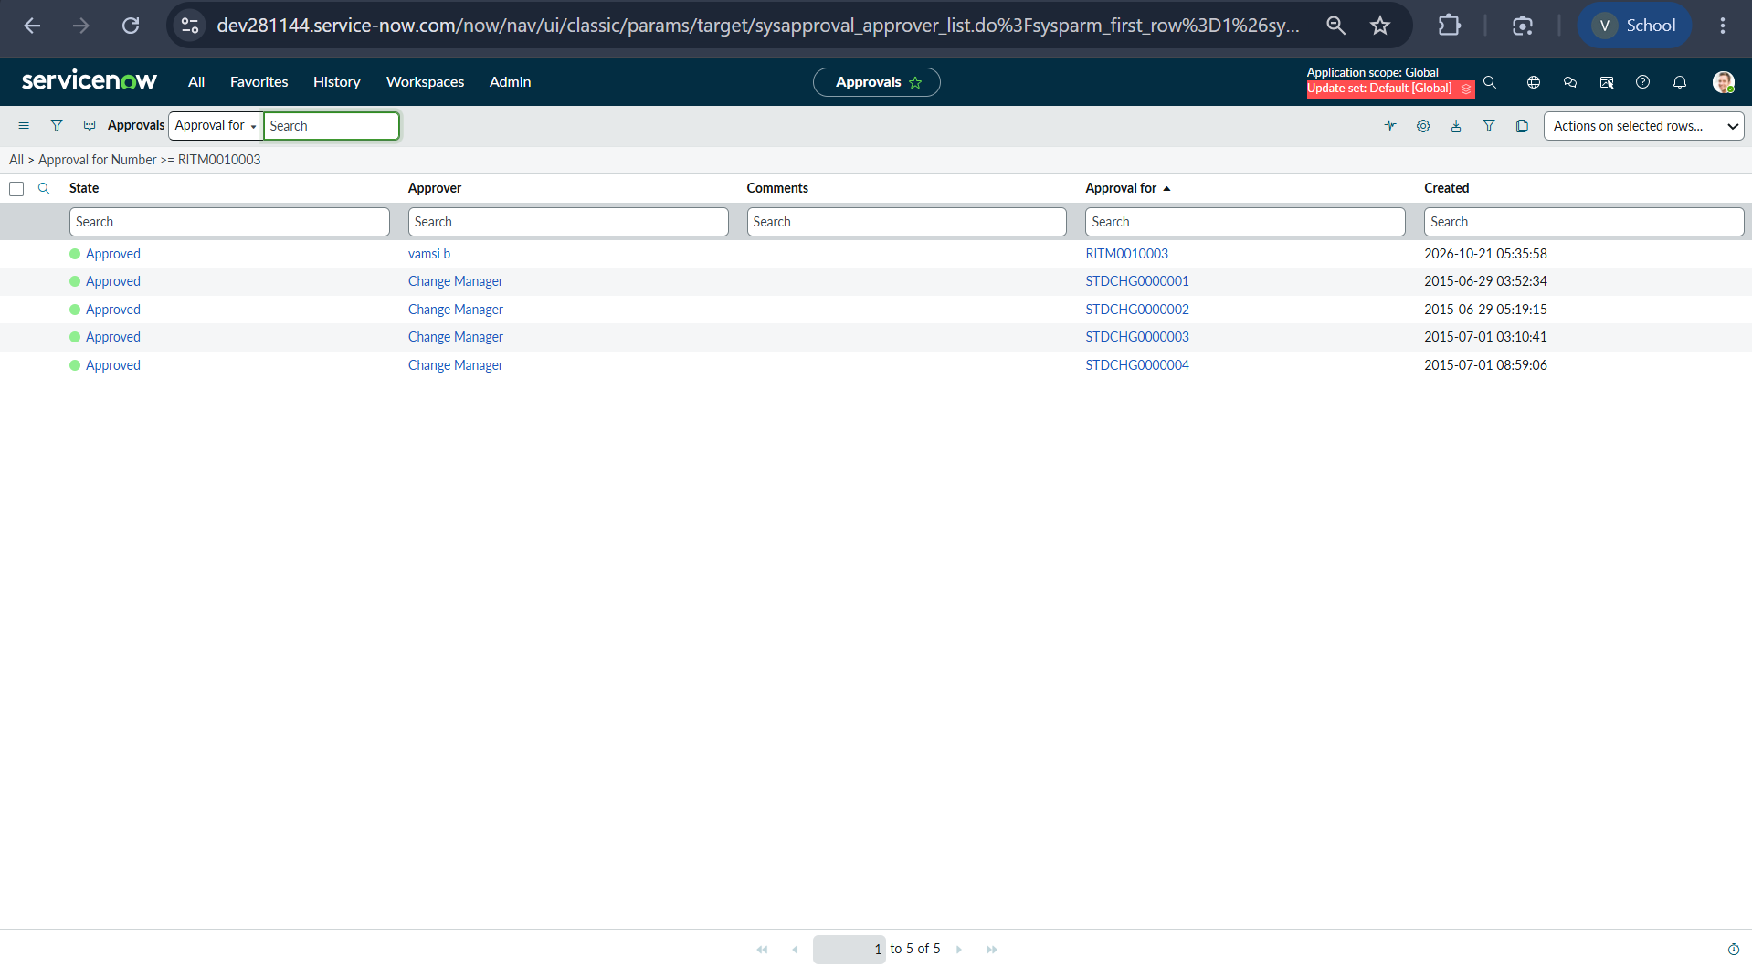
Figure 2: Approval record in the Approved state for the requested item
Scenario 4: Request Status Verification by the User
- After the approval, the user opens the requested item (RITM0010001 in this test) to check the outcome.
- The item is Car Rental Request, the Stage reads “Request Approved” and the State reads “Closed Complete”.
- All submitted values are stored correctly: Requested Date 2026-10-21, Pickup Location visakhapatnam, Drop Location jonnada, Duration 1 hour, Car Type fortuner and Reason family function.
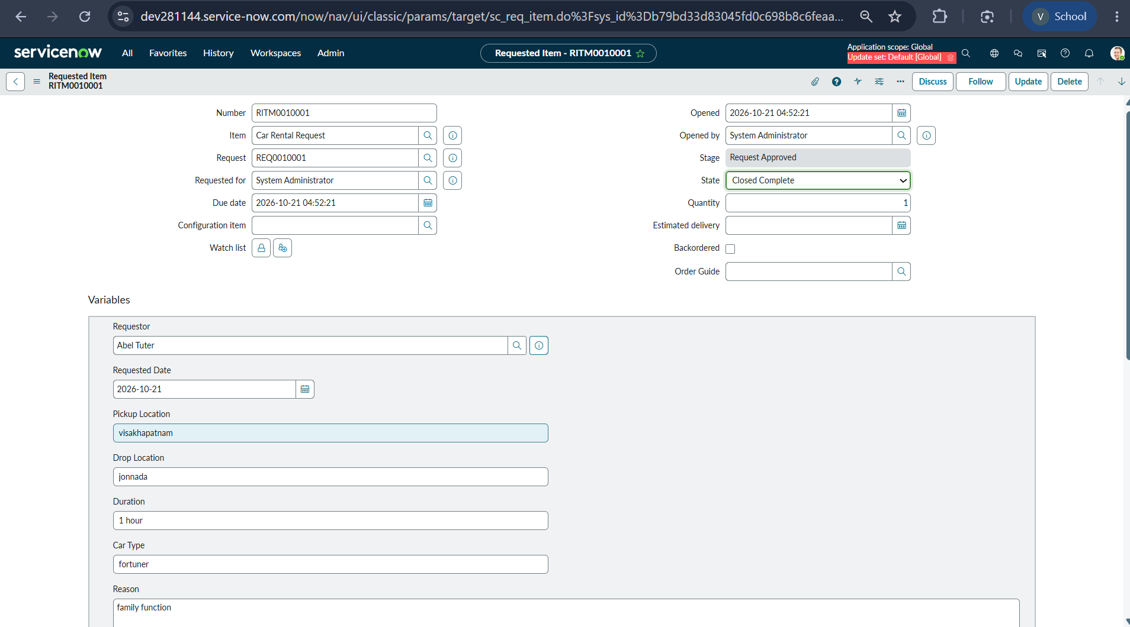
Figure 3: Requested item showing the Request Approved stage and Closed Complete state
Test Results
Test case | Expected result | Actual result | Status
Submit car rental request | Request is submitted and a REQ number is generated | REQ0010002 generated along with the confirmation message | Pass
Flow Designer trigger | Flow runs when the catalog item is submitted | REQ and RITM created and the flow executed | Pass
Email to administrator | Office / administrator receives the notification | Administrator opened the email successfully | Pass
Administrator approval | Approval is recorded as Approved | Approval record found in the Approved state | Pass
User verification | Stage and state are updated and variables are stored | Request Approved and Closed Complete, with correct values | Pass
Summary
The results show that the Car Rental Request Automation system works reliably in every scenario tested. Placing the order, sending the email, the administrator’s approval and the automatic status updates all behave correctly, giving a consistent and error-free request process. The system is validated as ready for deployment and real-time use.

